Mathematics Pre-Assessment for Entry
[Day] [Month] [Year]
Examination Paper
Sample Pre-Assessment
Answer ALL questions. Clearly cross out surplus answers.
Time: 1 hour
The maximum mark for this paper is 50.
Any reference material brought into the examination room must be handed to the invigilator before the start of the examination.
Candidates are allowed to use a scientific calculator during this examination.

Q1. Simplify the following expressions
- $12a+14b-7a+8b$ (2 marks)

- $8w^{2}+7w^{3}+5w^{2}+8w^{3}$ (2 marks)

Q2. Solve $7x-9=75$ (2 marks)

Q3. (a) Factorise $x^{2}+8x+15$
(2 marks)

(b) Hence or otherwise, solve the equation $x^{2}+8x+15=0$ (2 marks)

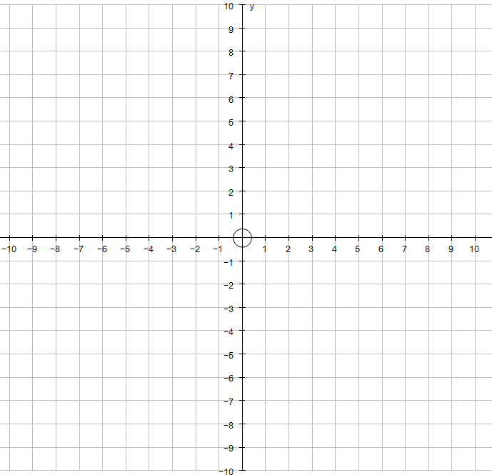
Q4. On the grid below, plot the linear graph with equation $y=3x-1$

(2 marks)
Q5. $ε=1, 2, 3, 4, 5, 6, 7, 8, 9, 10, 11, 12$
A = Multiples of 3
B = Multiples of 4
(a) Complete the Venn diagram below
$ε$
A B

(2 marks)
(b) Calculate the probability of $P(A∩B)$
(2 marks)
Q6. If A= $\left(\begin{matrix}2 & -3 \\ 3 & 1\end{matrix}\right)$ and B = $\left(\begin{matrix}0 & 4 \\ -2 & 5\end{matrix}\right)$
(a) Calculate the matrix 4A
(1 mark)
(b) Calculate the matrix A+B
(1 mark)

Q7. A class of 40 students were asked about their favourite football teams. The results are as follows:
Football team | Frequency
Manchester City | 14
Manchester United | 10
Liverpool | 9
Chelsea | 5
Other | 2

Represent this data in a pie chart below

(4 marks)
Q8. The table below shows the height of 60 students in centimetres.
Height of student (cm) | Frequency
120 < h ≤ 130 | 4
130 < h ≤ 135 | 10
135 < h ≤ 140 | 12
140 < h ≤ 150 | 20
150 < h ≤ 170 | 14

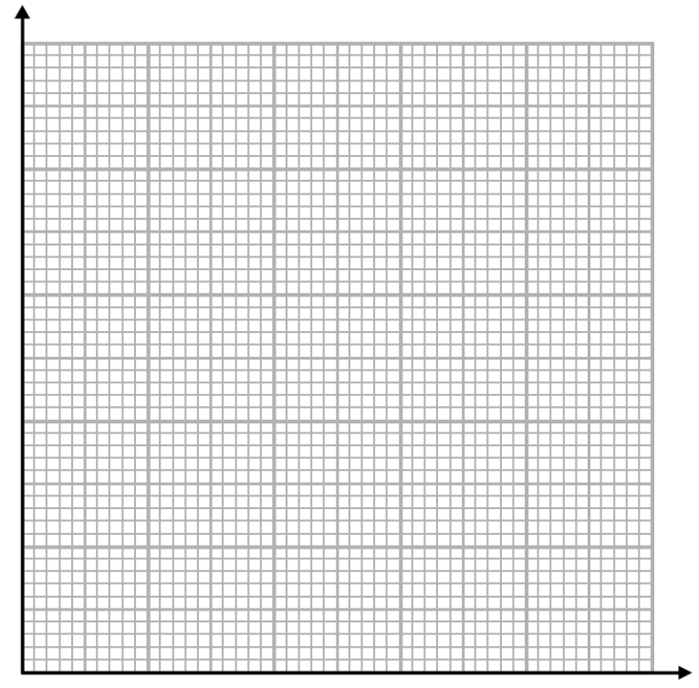
(a) On the grid below, draw a histogram to represent this data.

(3 marks)
(b) State the class interval that contains the median

(1 mark)
Q9. 20 students took a physics test and their scores are listed below:
5, 5, 6, 8, 9, 10, 10, 10, 11, 14, 14, 15, 16, 16, 17, 19, 20, 20, 23, 24
(a) Calculate the modal score achieved on the physics test
(1 mark)
(b) Calculate the range of the scores achieved on the physics test

(1 mark)
(c) Calculate the mean score achieved on the physics test

(2 marks)
Q10. The temperature of 8 swimming pools, in degrees Celsius ($℃)$, are listed below.

26$℃$ 24$℃$ 28$℃$ 26$℃$ 30$℃$ 28$℃$ 25$℃$ 27$℃$
(a) Calculate the mean of the data above

(2 marks)
(b) Calculate the variance of the data above

(2 marks)
(c) Calculate the standard deviation of the data above, rounding your answer to 2 decimal places

(2 marks)

Q11. Two fair dice are rolled and their scores are added together.
(a) Complete the sample space diagram below to show all of the possible outcomes
+ | 1 | 2 | 3 | 4 | 5 | 6
1
2
3
4
5
6
(2 marks)
(b) Calculate the probability of scoring a total of 7 when two fair dice a rolled and the scores added together.

(2 marks)

Q12. Kevin is going to play a game of chess and a game of backgammon.
The chance of winning a game of chess is 0.4 and the chance of winning a game of
backgammon is 0.7.
(a) Complete the probability tree below
Chess Backgammon
Win
……
……
0.7
0.7
……
0.4
Win
Win

Lose

Lose

Lose

(2 marks)
(b) Calculate the probability that Kevin wins both games

(2 marks)
(c) Calculate the probability that Kevin wins at least one game of chess.

(2 marks)

Q13. In a box there are red pens, black pens, blue pens and green pens.
A pen is taken at random from the box. The table below shows the probability of selecting
some of the colours of pen.
Colour of pen | Red | Black | Blue | Green
Probability | 0.22 | 0.34 | 0.11

(a) Calculate the probability of selecting a green pen from the box

(2 marks)
(b) There are 500 pens in the box. Calculate an estimate for the number of black pens in the box.

(2 marks)

