Mathematics Pre-Assessment for Entry
[Day] [Month] [Year]
Examination Paper
Sample Pre-Assessment
Answer ALL questions. Clearly cross out surplus answers.
Time: 1 hour
The maximum mark for this paper is 50.
Any reference material brought into the examination room must be handed to the invigilator before the start of the examination.
Candidates are allowed to use a scientific calculator during this examination.

Q1. (a) Evaluate $x^{0}$
(1 mark)
(b) Simplify ${\left({3x}^{4}\right)}^{2}$

(2 marks)
(c) Factorise ${12x}^{2}y^{4}+{18x}^{7}y^{3}$

(3 marks)
Q2. Simplify fully $\frac{x+4}{x^{2}-16}$

(3 marks)
Q3. Solve $\frac{x+5}{3}+\frac{x+1}{2}=8$

(4 marks)
Q4. Solve $8x+41=5x+56$

(3 marks)
Q5. Work out the equation for the straight line graph on the grid below
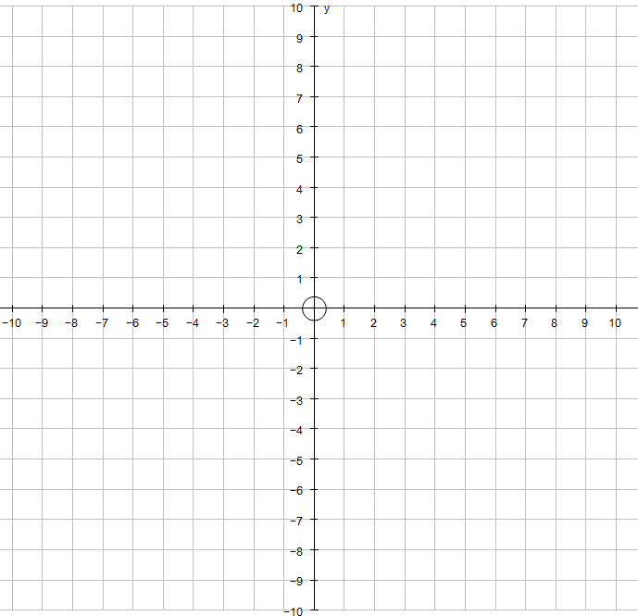

(2 marks)
Q6. Let A=$\{0,1,2,3,4\}$ and B={$2,4,6,8,10$}
(a) State the values for $A∪B$
(2 marks)
(b) State the values for $A∩B$

(1 mark)
Q7. For $M=\left(\begin{matrix}3 & 1 \\ -1 & 3\end{matrix}\right)$ work out the image of the point A = (1,5) under the transformation represented by M.

(3 marks)
Q8. The data below shows the amount of money 20 students said they had in their savings accounts

£340 | £298 | £177 | £415 | £365 | £288 | £279 | £189 | £208 | £411
£333 | £445 | £150 | £89 | £421 | £390 | £448 | £273 | £299 | £401

Complete the table below to represent this data
Amount of savings (£) | Frequency | Cumulative Frequency
0 ≤ £ < 100
100 ≤ £ < 200
200 ≤ £ < 300
300 ≤ £ < 400
400 ≤ £ < 500

(3 marks)

Q9. The frequency table shows the height, in cm, of some sunflowers
Height (cm) | Frequency
140 < h ≤ 150 | 7
150 < h ≤ 160 | 10
160 < h ≤ 170 | 15
170 < h ≤ 180 | 19
180 < h ≤ 190 | 9

(a) Draw a frequency polygon to represent this information.
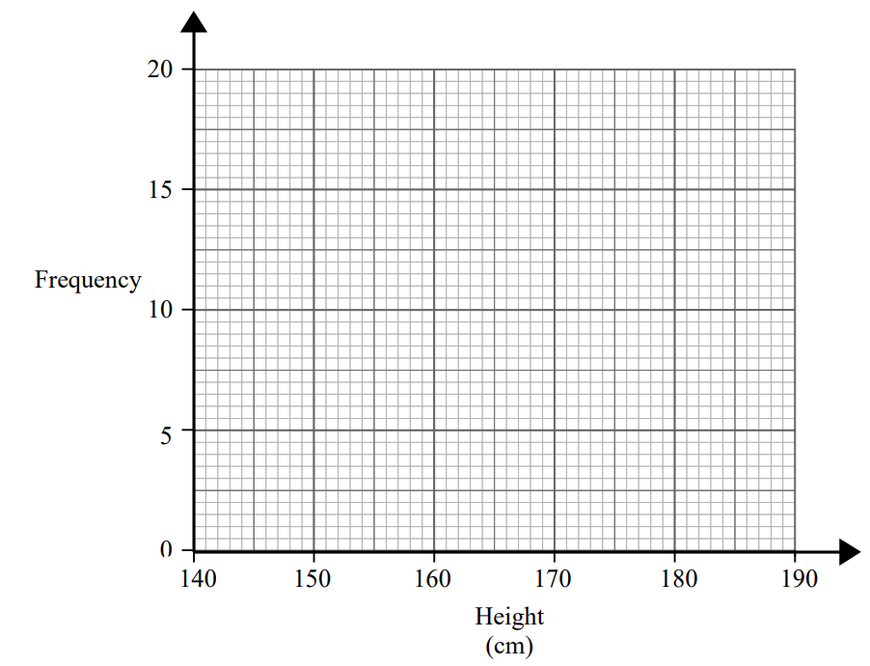

(2 marks)
(b) State the modal class interval

(1 mark)

(c) State the median class interval

(1 mark)

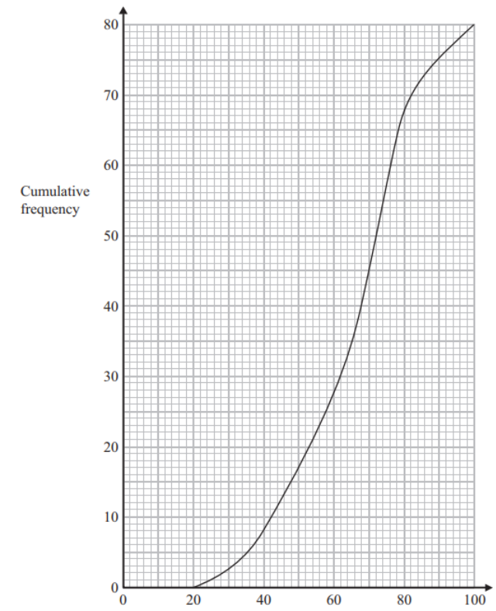
Q10. The cumulative frequency graph gives some information about the time taken, in minutes, to complete an assignment.

(a) Use the graph to calculate an estimate for the median time taken to complete the assignment
(2 marks)
(b) Use the graph to calculate an estimate for the interquartile range of time taken to complete the assignment
(3 marks)
(c) Calculate an estimate for the percentage of people who took longer than 80 minutes to complete the assignment.

(3 marks)
Q11. Find the mean deviation from the mean for the following data set.
59, 47, 59, 67, 64, 57, 43, 49, 44, 61
(4 marks)
Q12. There are 8 counters in a bag. 5 of the counters are green and 3 of the counters are red.
Two counters are taken from the bag at random.
Work out the probability of one of each colour being selected from the bag.

(4 marks)
Q13. In a rental car park there are cars, motorbikes and vans.
The probability of selecting a car to rent is $\frac{1}{4}$
The probability of selecting a motorbike is 35%
(a) Calculate the probability of selecting a van
(1 mark)
(b) Calculate the probability of not selecting a car

(2 marks)

