Mathematics Pre-Assessment for Entry
[Day] [Month] [Year]
Examination Paper
Sample Pre-Assessment
Answer ALL questions. Clearly cross out surplus answers.
Time: 1 hour
The maximum mark for this paper is 50.
Any reference material brought into the examination room must be handed to the invigilator before the start of the examination.
Candidates are allowed to use a scientific calculator during this examination.

Q1. Simplify ${20x}^{14}×{4x}^{6}$
(2 marks)
Q2. Simplify $\frac{24a^{12}b^{4}}{{8a}^{7}b}$

(2 marks)
Q3. Expand and simplify $(2x+4)(x-5)$

(2 marks)
Q4. Simplify $\frac{x+5}{3}+\frac{x-1}{4}$

(3 marks)
Q5. Make x the subject of the formula of $\sqrt{3x-4}=y$

(3 marks)
Q6. Solve the simultaneous equations $5x+3y=26$
$3x+y=14$

(4 marks)
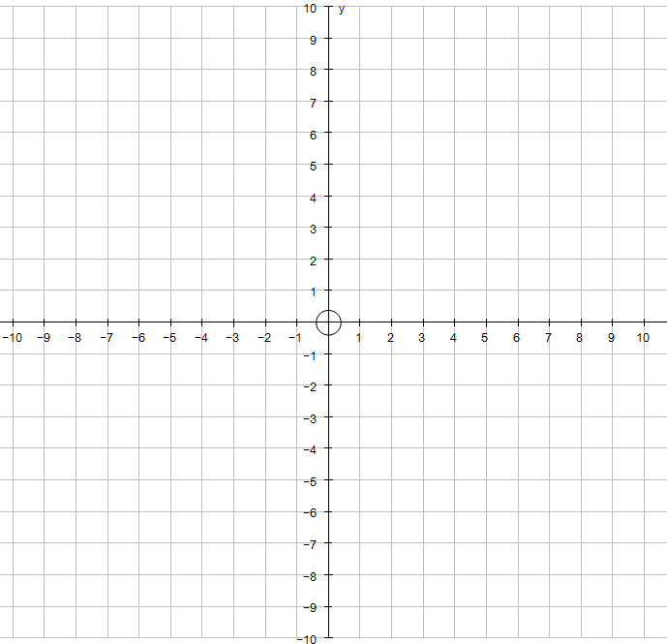
Q7. The graphs of the straight lines with equations $y=x+2$ and $2x+3y=16$ have been drawn on the grid.
Use the graphs to solve the simultaneous equations $y=x+2$ and $2x+3y=16$.

(2 marks)
Q8. (a) Complete the table of values for the equation $y=x^{2}-2x-5$
x | -3 | -2 | -1 | 0 | 1 | 2 | 3
y

(2 marks)
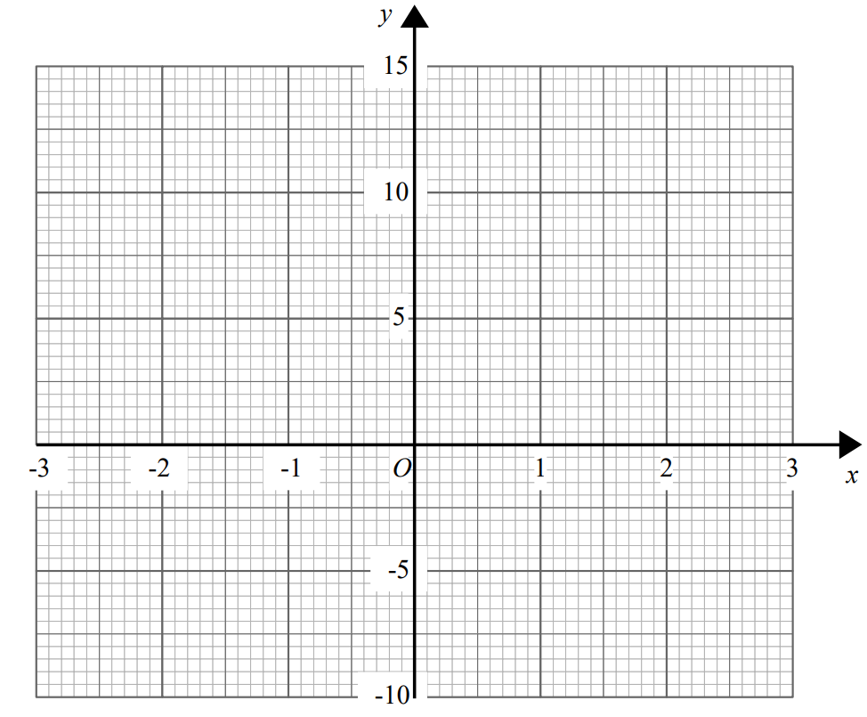
(b) On the grid below, draw the graph for $y=x^{2}-2x-5$ for values of x from 3 and -3

(2 marks)
Q9. On the Venn diagram below, shade the area which represents the set $P(A∪B)$

A B

(2 marks)
Q10. Fill in the missing values in the identity matrix below.
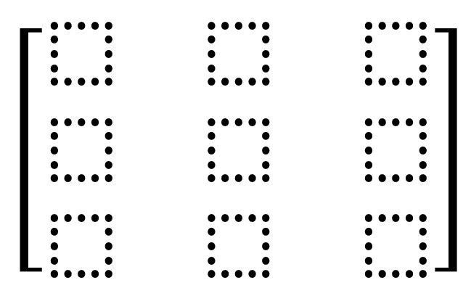
$$I_{3}=$$
(3 marks)

Q11. The matrix A = $\left[\begin{matrix}3 & 1 \\ 0 & -2 \\ 3 & 0\end{matrix}\right]$ and B = $\left[\begin{matrix}1 & 0 \\ 4 & 3 \\ 0 & 2\end{matrix}\right]$.

(a) Calculate A – B

(2 marks)
Matrix C = $\left[\begin{matrix}4 & 5 & 6\end{matrix}\right]$ and D = $\left[\begin{matrix}1 \\ 2 \\ 3\end{matrix}\right]$
(b) Multiply C by D

(2 marks)

Q12. The table below shows information about the number of pints of milk a milkman delivered each day from Monday to Friday.

Day | Monday | Tuesday | Wednesday | Thursday | Friday
No. of pints | 30 | 62 | 68 | 43 | 17

Represent the information below as a bar chart on the grid provided below.
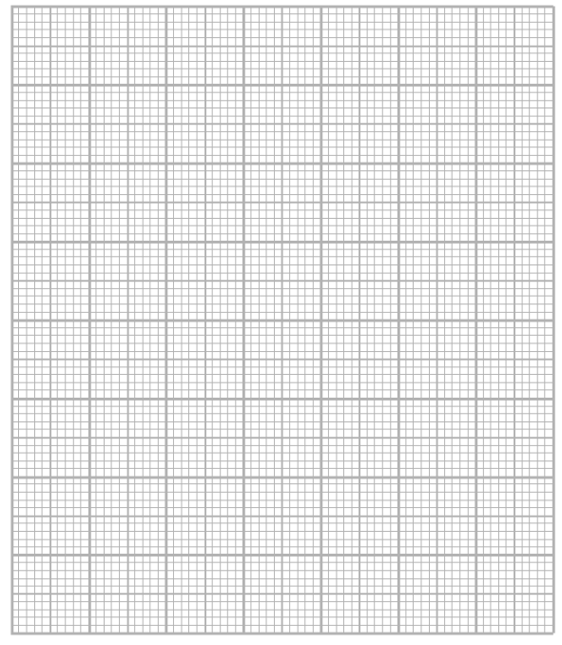

(3 marks)
Q13. Here is a list of the heights of 15 people, measured in centimetres.
175cm, 168cm, 170cm, 181cm, 169cm, 175cm, 183cm, 178cm
173cm, 185cm, 159cm, 169cm, 171cm, 174cm, 172cm
(a) Complete the table below
Lowest value
Lower quartile
Median
Upper quartile
Highest value
(3 marks)
(b) Represent the data as a box plot on the grid below

(3 marks)
Q14. Below are five representations of scatter graphs along with descriptions of their correlation
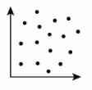
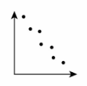
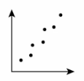
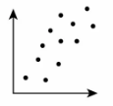
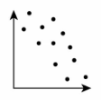

E
D
B
C
A

Correlation description | Graph letter
Strong positive
Weak positive
No correlation
Weak negative
Strong negative

(3 marks)
Q15. The data below shows the time taken for 50 students to complete an assessment.
Time (t seconds) | Frequency
5 ≤ t < 10 | 9
10 ≤ t < 15 | 13
15 ≤ t < 20 | 17
20 ≤ t < 25 | 11

(a) State the modal class interval
(1 mark)
(b) State the median class interval
(1 mark)
(c) Calculate an estimate for the mean time taken for the students to complete the assessment

(4 marks)
Q16. A fair dice is rolled. Calculate the probability the number rolled is a 6.

(1 mark)

