Mathematics Pre-Assessment for Entry
[Day] [Month] [Year]
Examination Paper
Sample Pre-Assessment
Mark Scheme
Time: 1 hour
The maximum mark for this paper is 50.

Question | Answer | Mark allocation
Q1(a) | 5a + 22b | 1 mark for 5a correct  1 mark for 22b correct
Q1(b) | $${13w}^{2}+{15w}^{3}$$ | 1 mark for ${13w}^{2}$ correct  1 mark for ${15w}^{3}$ correct
Q2 | x = 12 | 1 mark for adding 9 to get 7x = 84  1 mark for dividing by 7 to get x = 12
Q3(a) | $$\left(x+3\right)\left(x+5\right)$$ | 1 mark for stating the values 3 and 5  1 mark for fully correct brackets
Q3(b) | x = -3 and x = -5 | 1 mark for x = -3 seen  1 mark for x = -5 seen
Q4 | 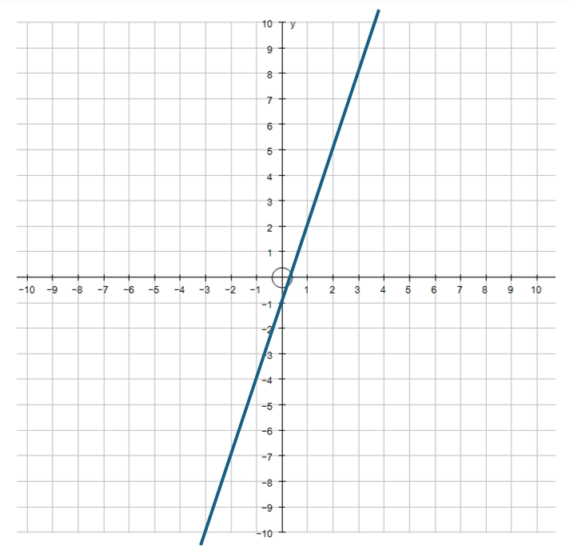 | 1 mark for a linear graph with a gradient of 3  1 mark for a linear graph with a  y-intercept of (0,-1)
Q5(a) | 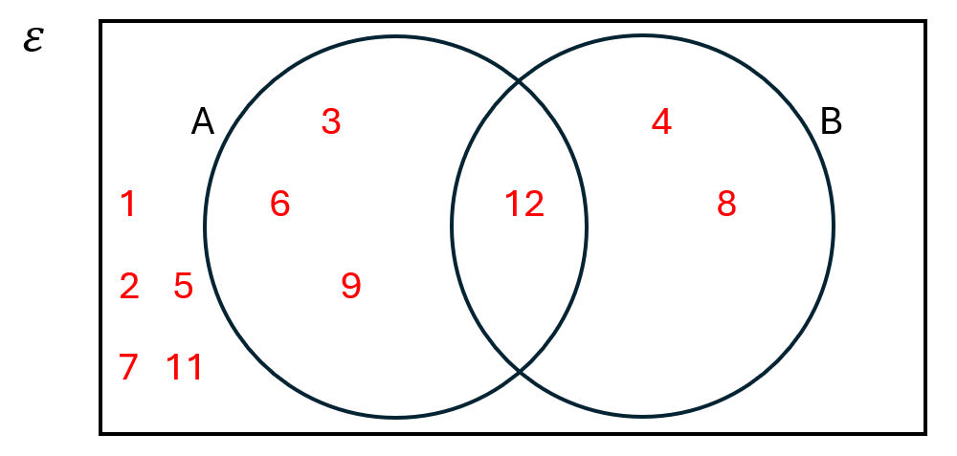 | 1 mark for 2 or 3 correct sections of the Venn filled in correctly  2 marks for a fully correct Venn diagram
Q5(b) | $$\frac{1}{12}$$ | 1 mark for $\frac{n}{12}$ where n > 1  2 marks for fully correct fraction
Q6(a) | 4A= $\left(\begin{matrix}8 & -12 \\ 12 & 4\end{matrix}\right)$ | 1 mark for correct answer only
Q6(b) | A + B = $\left(\begin{matrix}2 & 1 \\ 1 & 6\end{matrix}\right)$ | 1 mark for correct answer only
Q7 | 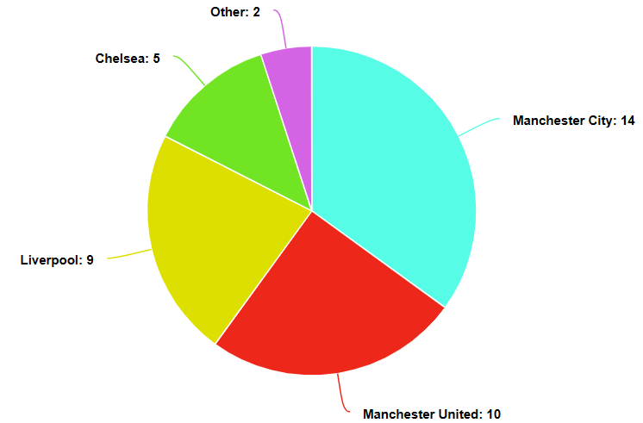  126$°$  45$°$  90$°$  81$°$  18$°$ | 1 mark for calculating 360÷40=9 (9$°$ per 1 person in the survey)  1 mark for calculating the correct angles of 126$°$, 90$°,$ 81$°$, 45$°$ and 18$°$  1 mark for accurate pie chart drawn  1 mark for all sections of pie chart labelled
Q8(a) |  | 1 mark for calculating the frequency density values of 0.4, 2, 2.4, 2 and 0.7 respectively  1 mark for accurately setting the scale on the x and y axes  1 mark for all 5 bars drawn accurately
  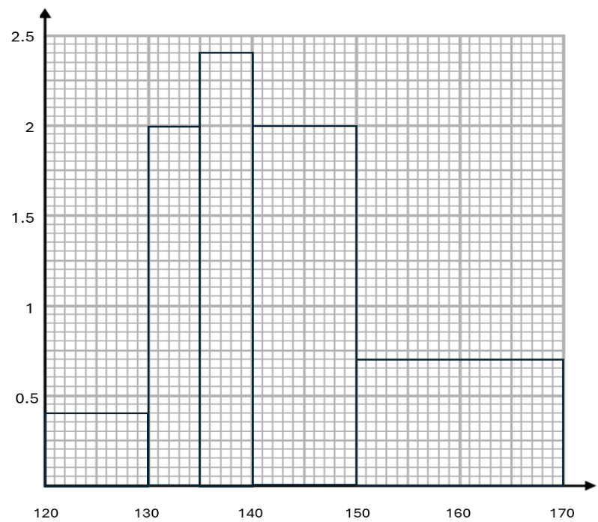
Q8(b) | 140 < h ≤ 150 | 1 mark for correct answer only (condone one symbol error)
Q9(a) | 10 | 1 mark for correct answer only
Q9(b) | 19 | 1 mark for correct answer only
Q9(c) | 13.6 | 1 mark for adding up the data to get 272  1 mark for calculating 272 ÷ 20 = 13.6
Q10(a) | 26.75 | 1 mark for adding the values to get 214  1 mark for 214÷8=26.75
Q10(b) | 3.6428571 | 1 mark for calculating the difference from the mean and squaring the values  1 mark for continuing with the process to get 3.6428571 (accept rounded answer)
Q10(c) | 1.908627 (1.91 to 2 decimal places) | 1 mark for using the substituting the values into the SD formula  1 mark final answer (accept full answer or rounded to 2dp)
Q11(a) | 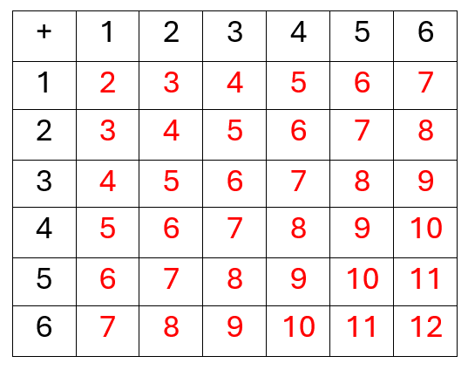 | 1 mark for a correct grid with one calculation error  2 marks for a fully correct sample space
Q11(b) | $$\frac{6}{36}or\frac{1}{6}$$ | 1 mark for correct answer followed through from part a  2 marks for correct fraction seen (can be simplified)
Q12(a) | 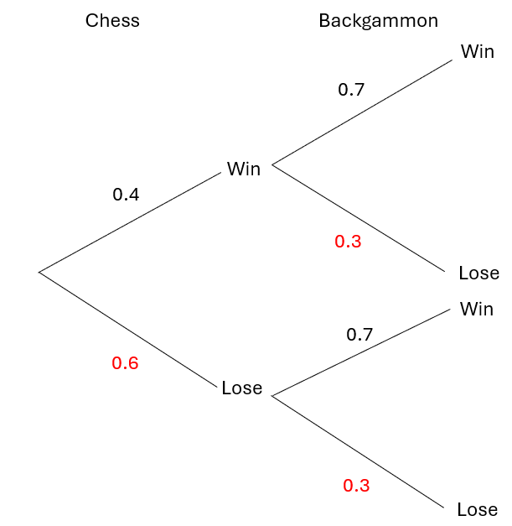 | 1 mark for 0.6 seen for losing a chess game  1 mark for 0.3 seen for losing backgammon
Q12(b) | 0.4 x 0.7 = 0.28 | 1 mark for intent to multiply 0.4 by 0.7  2 marks for correct answer seen
Q12(c) | Win/win 0.4 x 0.7 = 0.28  Win/lose 0.4 x 0.3 = 0.12  Lose/win 0.6 x 0.7 = 0.42  0.28 + 0.12 + 0.42 = 0.82 | 1 mark for calculating at least two of these three calculations  2 marks for correct answer seen
Q13(a) | 1 – 0.67 = 0.33 | 1 mark for 0.67 seen  2 marks for 0.33 seen
Q13(b) | 500 x 0.34 = 170 black pens | 1 mark for 500 x 0.34 seen  2 marks for 170 seen

