Mathematics Pre-Assessment for Entry
[Day] [Month] [Year]
Examination Paper
Sample Pre-Assessment
Mark Scheme
Time: 1 hour
The maximum mark for this paper is 50.

Question number | Answer | Mark allocation
Q1(a) | 1 | M1 correct answer only
Q1(b) | $${9x}^{8}$$ | M1 for $3^{2}=9$ or $x^{8}$ seen  M2 for fully correct answer
Q1(c) | $${6x}^{2}y^{3}(2y+{3x}^{5})$$ | M1 for ${6x}^{2}y^{3}$  M2 for ${6x}^{2}y^{3}$ and one correct term inside the brackets or for a correct factorisation but not fully factorised  M3 for a fully factorised answer
Q2. | $$\frac{1}{x-4}$$ | M1 for factorising the denominator to get (x+4)(x-4)  M2 for intention to cancel out (x+4) from top and bottom  M3 for fully correct answer
Q3. | x = 7 | M1 for multiplying to get a common denominator of 6  M2 bringing the fraction together as one fraction with the terms 2x+10+3x+3 or 5x+13  M3 for multiplying both sides by 6 to eliminate the denominator  M4 for solving the equation to get x=7
Q4. | x = 5 | M1 for a 1st step of either subtracting 41 from both sides, or subtracting 5x from both sides  M2 for doing both of these to get 3x=15  M3 for an answer or x = 5
Q5. | $$y=4x-2$$ | M1 for either 4x or -2 seen (or for an equation without y=)  M2 for fully correct equation
Q6(a) | 0,1,2,3,4,6,8,10 | M1 for a correct list with repeats not removed (or one value missing)  M2 for a fully correct list
Q6(b) | 2 and 4 | M1 for correct answer only
Q7. | A’ = (8,14) | M1 for multiplying the matrix by a matrix of $\left(\begin{matrix}1 \\ 5\end{matrix}\right)$  M2 for converting the resultant matrix to a co-ordinate
Q8. | 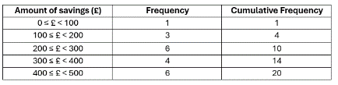 | M1 for a method of organising the data to allow for counting  M2 for a fully correct frequency column  M3 for a fully correct table filled in
Q9(a) | 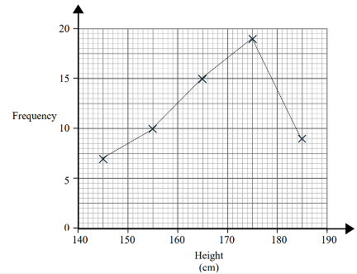 | M1 for a plotting the points using the midpoints  M2 for fully correct frequency polygon drawn
Q9(b) | 170 < h ≤ 180 | M1 for correct answer only
Q9(c) | 160 < h ≤ 170 | M1 for correct answer only
Q10(a) | 66 – 69 | M1 for drawing the estimation lines on the graph  M2 for an answer in the range 66-69
Q10(b) | 19 – 27 | M1 for an upper quartile value between 74 and 78  M1 for a lower quartile value between 51 and 55  M3 for an answer between 19 and 27
Q10(c) | 15% | M1 for drawing an estimation line up from 80 mins and across to approx. 68 (allow 67-69)  M1 for subtracting this from 80 t0 get 12 (allow 11 or 13)  M3 for 12÷80x100 = 15% (allow 14% - 16%)
Q11. | 7.4 | M1 for calculating the mean of the data as 55  M2 for calculating the difference between 55 and all of the data values  M3 for adding up these values and attempting to divide by 10  M4 for a mean of 7.4
Q12. | $$\frac{30}{56}$$ | M1 for calculating 2 green as $\frac{5}{8}×\frac{4}{7}=\frac{20}{56}$  M1 for calculating 2 red as $\frac{3}{8}×\frac{2}{7}=\frac{6}{56}$  M1 for calculating P(2 same)= $\frac{26}{56}$  M1 for calculating $\frac{30}{56}$
Q13(a) | 40% | M1 for correct answer seen (accept as a decimal or fraction)
Q13(b) | $$\frac{3}{4}$$ | M1 for 1 – $\frac{1}{4}$  M2 for $\frac{3}{4}$ or seen as a decimal or percentage

