Mathematics Pre-Assessment for Entry
[Day] [Month] [Year]
Examination Paper
Sample Pre-Assessment
Mark Scheme
Time: 1 hour
The maximum mark for this paper is 50.

Question number | Answer | Mark allocation
Q1. | $${80x}^{20}$$ | M1 for two out of 80, x and the power 20 correct  M2 for fully correct answer
Q2. | $${3a}^{5}b^{3}$$ | M1 for two parts correct out of 3, $a^{5}$ or $b^{3}$ seen  M2 for fully correct answer
Q3. | $${2x}^{2}-6x-20$$ | M1 for three out of four correct from ${2x}^{2}-10x+4x-20$  M2 for fully correct simplified answer
Q4. | $$\frac{7x+17}{12}$$ | M1 for multiplying the first fraction by 4 and the second fraction by 3 to get a common denominator  M2 for $\frac{4x+20+3x-3}{12}$ or equivalent (if 12 not common denominator)  M3 for fully simplified fraction
Q5. | $$x=\frac{y^{2}+4}{3}$$ | M1 for correct first step of squaring both sides to get $y^{2}=3x-4$  M2 for correct 2nd step of adding 4 to both sides to get $y^{2}+4=3x$  M3 for fully correct answer
Q6. | x=4  y=2 | M1 for getting the x or y values matching in both equations (x 2nd equation by 3)  M2 for subtracting the equations and calculating x=4  M3 for substituting x into one of the equations to find y  M4 for both solutions correct
Q7. | x=2  y=4 | M1 for identifying the  co-ordinate (2,4)  M2 for stating the correct solutions not in co-ordinate form
Q8(a) | x -3 -2 -1 0 1 2 3  y 10 3 -2 -6 -5 -5 -2 | M1 for at least 5 correct values calculated  M2 for fully correct table of values
Q8(b) | 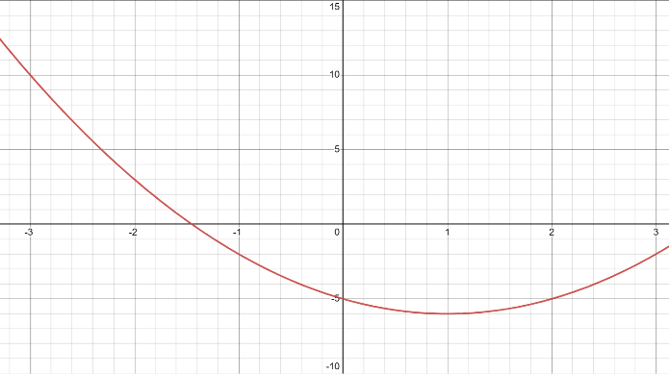 | M1 for at least 5 out of 6 points plotted from their table above  M2 for a fully correct curve drawn
Q9. | 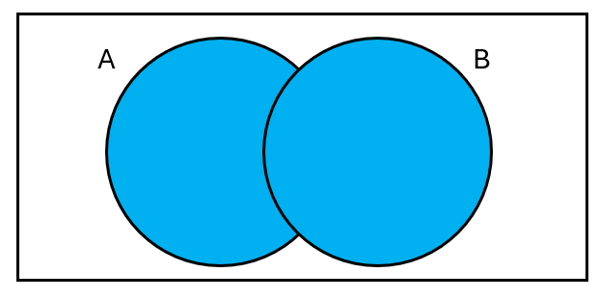 | M1 for either A or B fully shaded in only  M2 for fully correct region shaded in
Q10. | $$\left[\begin{matrix}1 & 0 & 0 \\ 0 & 1 & 0 \\ 0 & 0 & 1\end{matrix}\right]$$ | M1 for the 1 values correct through the diagonal  M2 for only 0 and 1 used in the matrix  M3 for fully correct identity matrix
Q11(a) | $$\left[\begin{matrix}2 & 1 \\ -4 & -5 \\ 3 & -2\end{matrix}\right]$$ | M1 for at least 4 values correct in the matrix  M2 for a fully correct matrix
Q11(b) | $\left[\begin{matrix}4×1 & 4×2 & 4×3 \\ 5×1 & 5×2 & 5×3 \\ 6×1 & 6×2 & 6×3\end{matrix}\right]$ = $\left[\begin{matrix}4 & 8 & 12 \\ 5 & 10 & 15 \\ 6 & 12 & 18\end{matrix}\right]$ | M1 for 6 or more correct values in the matrix  M2 for a fully correct matrix
Q12 | 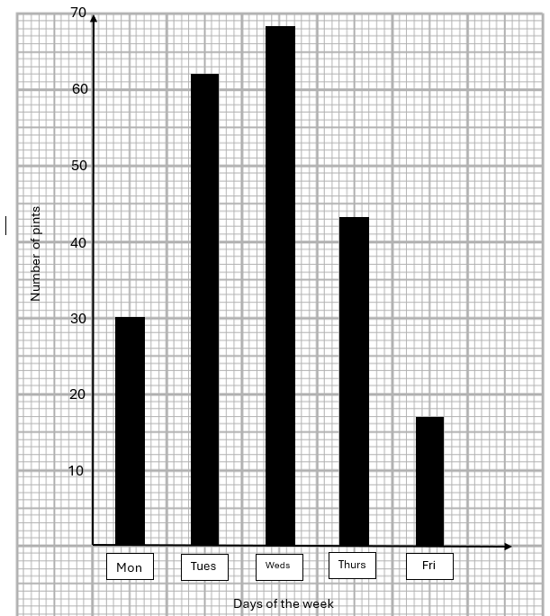 | M1 for correct x and y axis intervals (and labels)  M2 gaps between the bars for discrete data  M3 for at least 3 bars correct heigh  M4 for a fully correct bar chart
Q13 | Lowest value – 159cm  Lower quartile – 169cm  Median – 173cm  Upper quartile – 178cm  Highest value – 185cm | M1 for putting the data into ascending order  M2 for 3 correct values calculated (1 of which must be the median)  M3 for all 5 correct values
Q14 | C  D  A  E  B | M1 for 1 or 2 correct matches  M2 for 3 or 4 correct matches  M3 for all correct matches
Q15(a) | 15 ≤ t < 20 | M1 correct answer only (allow mistake with inequalities)
Q15(b) | 15 ≤ t < 20 | M1 correct answer only (allow mistake with inequalities)
Q15(c) | Midpoints Midp. x freq.  7.5 67.5  12.5 162.5  17.5 297.5  22.5 247.5  775 ÷ 50 = 15.5 | M1 for correct midpoints worked out  M2 for calculating midp. x freq column correctly  M3 for 775 ÷ 50  M4 for 15.5 seen
Q16 | $$\frac{1}{6}$$ | M1 for correct answer only

